THE UNIVERSITY OF AZAD JAMMU & KASHMIR

Student Name: Qurat Ul Ain Fatima
Roll No: 2024-SE-05
Course Title: Database Systems
Course Code: CS-2204
Lab Instructor: Awais Rathore
Department: Software Engineering

DBMS Open-Ended Lab Report

Car Rental Management System

1. Introduction:
A Car Rental Management System is a relational database system designed to manage the daily operations of a car rental company. The system stores and manages information about customers, vehicles, rentals, returns, and payments.
In the given scenario, CarGo Rentals currently manages its information using spreadsheets. As the number of rentals increases, spreadsheets can cause duplicate information, inconsistent records, and difficulties in preparing reports. Therefore, a proper relational database system is required.
The proposed system organizes the information into related tables and uses SQL features such as primary keys, foreign keys, constraints, normalization, JOINs, views, triggers, and stored procedures.
The system also ensures that a vehicle already rented to one customer is not treated as available for another rental. Management can use the database to obtain customer rental history, currently rented vehicles, and vehicle rental activity.

2. Overview:
The purpose of this project is to design and develop a complete database solution for a local car rental company.
The database will maintain:
- Customer information
- Vehicle information
- Rental information
- Return information
- Payment information
- Rental charges
- Current vehicle rental status
The original problem states that the company needs to record rentals and returns, calculate rental charges, maintain payment information, and generate useful management reports.

3. Problem Statement:
CarGo Rentals is experiencing problems because its business information is maintained using spreadsheets.
The major problems are:
- Duplicate customer and vehicle information.
- Inconsistent records.
- Difficulty updating information.
- Difficulty generating reports.
- Risk of renting an already rented vehicle.
- Difficulty calculating rental charges.
- Difficulty maintaining payment information.
- Data redundancy and possible data anomalies.
A relational database can solve these problems by dividing information into appropriate tables and connecting the tables using primary and foreign keys.

4. Objectives:
The main objectives of this project are:
- To design a relational database for car rental management.
- To create appropriate tables and attributes.
- To define primary and foreign keys.
- To apply suitable constraints.
- To insert realistic sample data.
- To normalize rental information up to 3NF.
- To use JOIN queries for business reports.
- To create a useful database VIEW.
- To create a TRIGGER for business validation or automation.
- To create a STORED PROCEDURE for rental operations.
- To identify a database performance problem.
- To suggest an optimization.
- To demonstrate the working of the database using SQL queries.

5. Proposed Database Design:
A suitable database can contain the following main tables:

5.1 Customer Table:
This table stores information about customers.
Possible attributes:
- CustomerID — Primary Key
- CustomerName
- CustomerPhone
- CustomerEmail
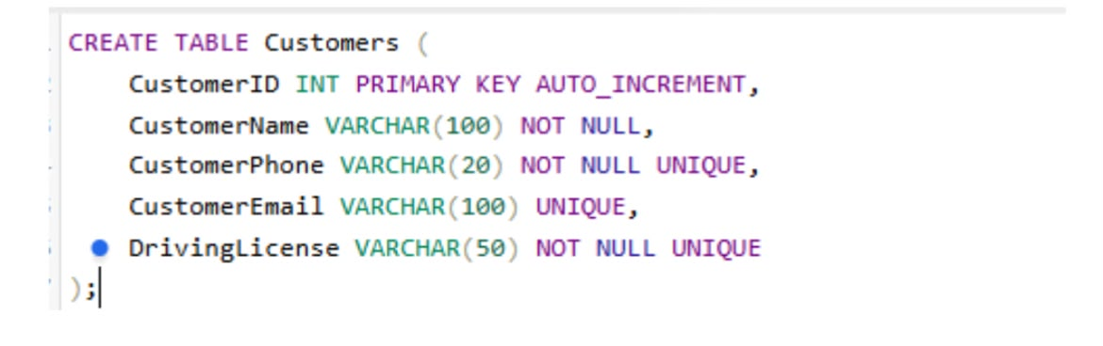

5.2 Vehicle Table:
This table stores information about rental vehicles.
Possible attributes:
- VehicleID — Primary Key
- VehicleNumber — Unique
- VehicleModel
- VehicleYear
- DailyRate
- VehicleStatus
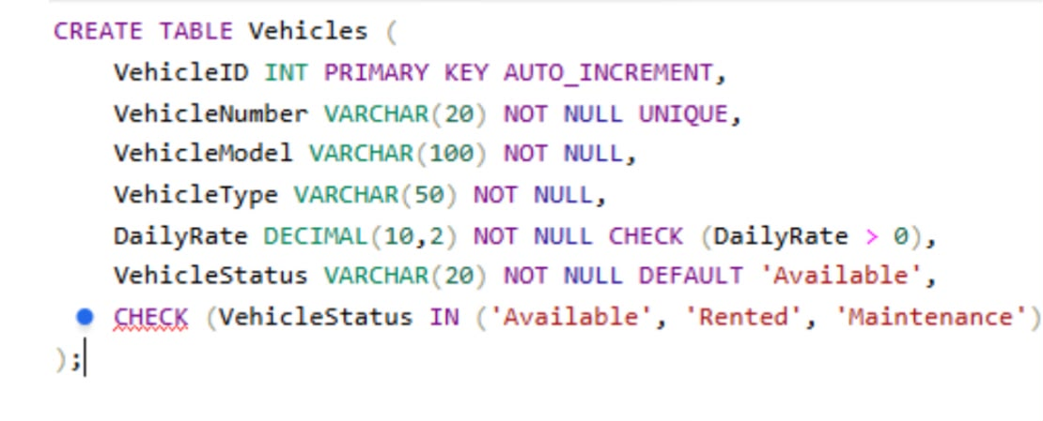

5.3 Rental Table:
This table records each rental transaction.
Possible attributes:
- RentalID — Primary Key
- CustomerID — Foreign Key
- VehicleID — Foreign Key
- RentalDate
- ReturnDate
- RentalStatus
- TotalAmount
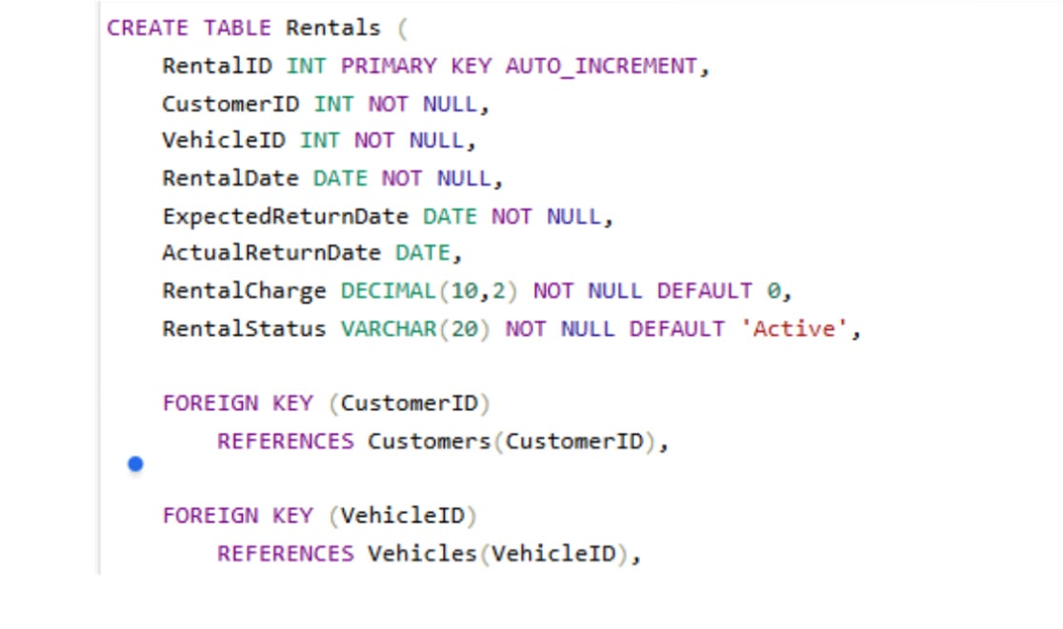

5.4 Payment Table:
This table stores payment information.
Possible attributes:
- PaymentID — Primary Key
- RentalID — Foreign Key
- PaymentAmount
- PaymentDate
- PaymentMethod
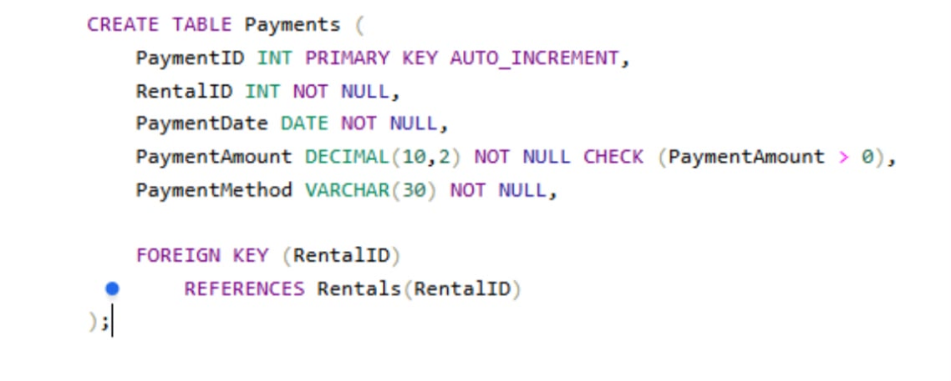

6. Primary Keys and Foreign Keys:

Primary Key:
A primary key uniquely identifies each record in a table.
Examples:
- CustomerID in Customer
- VehicleID in Vehicle
- RentalID in Rental
- PaymentID in Payment

Foreign Key:
A foreign key creates a relationship between tables.
Examples:
- CustomerID in Rental references Customer.
- VehicleID in Rental references Vehicle.
- RentalID in Payment references Rental.
- RentalID in Return references Rental.
This structure reduces duplication and maintains relationships between related records.

7. Database Constraints:
The database should use appropriate constraints to maintain data accuracy.

NOT NULL:
Used when a value is required.
Example:
CustomerName VARCHAR(100) NOT NULL

UNIQUE:
Used when duplicate values are not allowed.
Example:
VehicleNumber VARCHAR(20) UNIQUE

CHECK:
Used to restrict invalid values.
Example:
DailyRate DECIMAL(10,2) CHECK (DailyRate > 0)

DEFAULT:
Used to provide an automatic value.
Example:
VehicleStatus VARCHAR(20) DEFAULT 'Available'
These constraints are specifically part of the database-design requirements in the lab.

8. Sample Data:
Realistic sample data should be inserted into the database.
Customer Data:
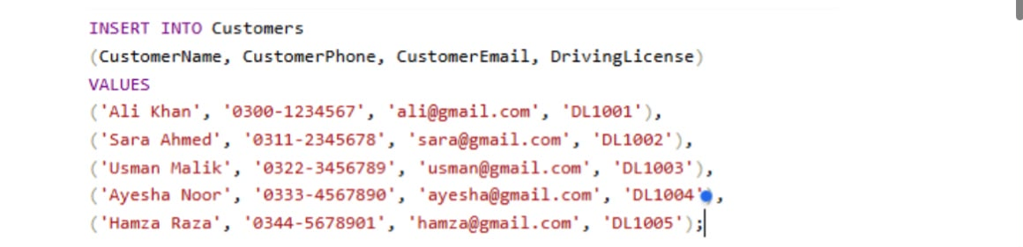

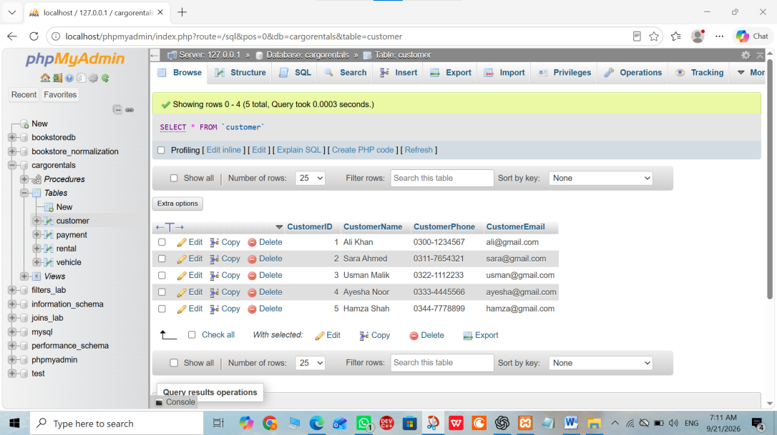
Vehicle Data:
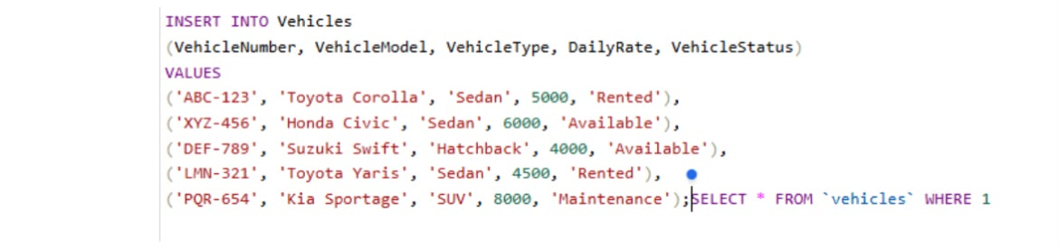
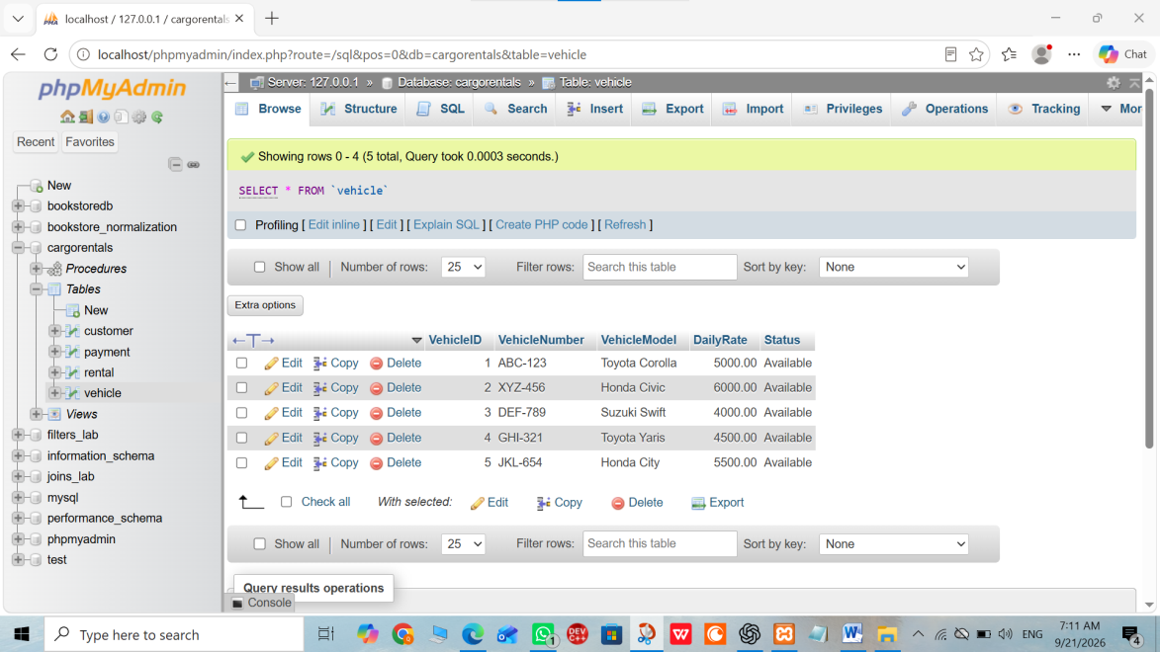
Rental Data:
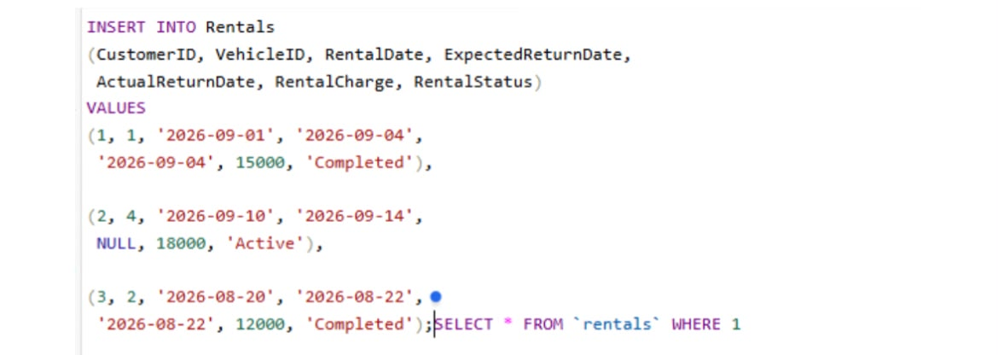
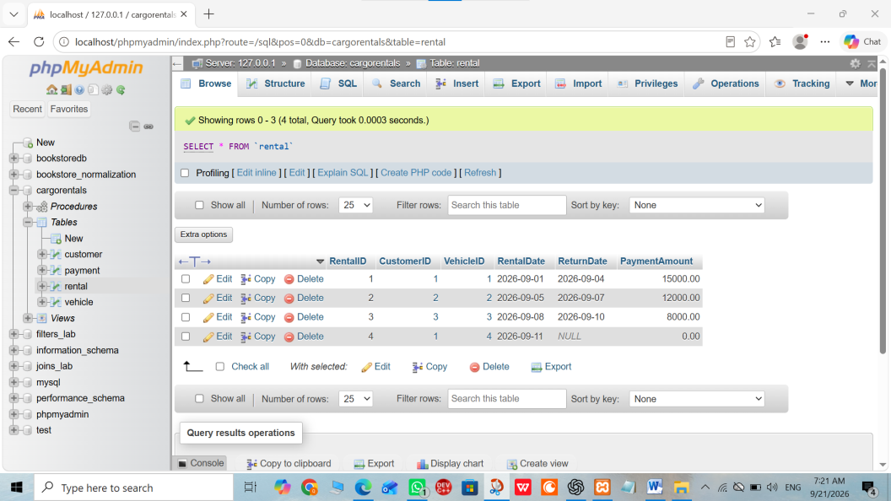
Payment Data:
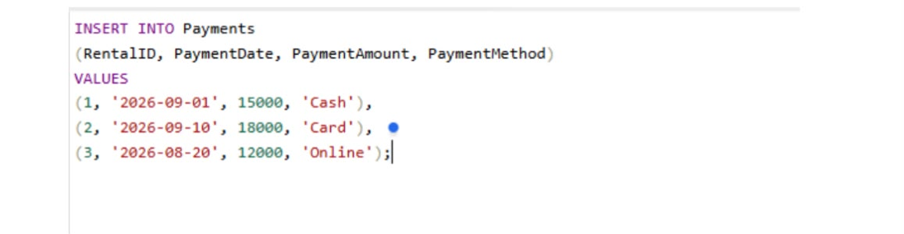
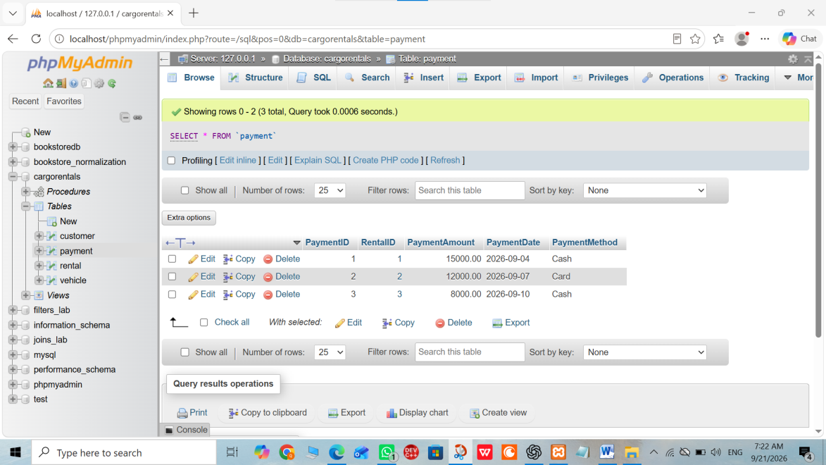

9. Normalization:
Normalization is an important part of this project. It reduces redundancy and prevents data anomalies.
The given unnormalized rental structure is:
RentalID, CustomerName, CustomerPhone, VehicleNumber, VehicleModel, DailyRate, RentalDate, ReturnDate, PaymentAmount
The lab provides the following example:
R001
Ali Khan
0300-1234567
ABC-123
Toyota Corolla
5000
2026-09-01
2026-09-04
15000
The task requires conversion into 1NF, 2NF, and 3NF, while explaining redundancy, dependencies, and anomalies.

10. First Normal Form (1NF):
A table is in 1NF when:
- Each column contains atomic values.
- There are no repeating groups.
- Each record can be uniquely identified.
The rental information can be organized as:
RentalID | CustomerName | CustomerPhone | VehicleNumber | VehicleModel | DailyRate | RentalDate | ReturnDate | PaymentAmount
R001 | Ali Khan | 0300-1234567 | ABC-123 | Toyota Corolla | 5000 | 2026-09-01 | 2026-09-04 | 15000
Each field contains one value, so the structure satisfies the basic requirement of 1NF.

11. Second Normal Form (2NF):
A table is in 2NF when:
- It is already in 1NF.
- There are no partial dependencies on part of a composite key.
To reduce dependency and redundancy, customer, vehicle, and rental information can be separated.

Customer
CustomerID
CustomerName
CustomerPhone
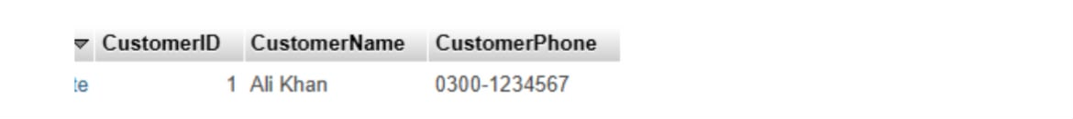

Vehicle
VehicleID
VehicleNumber
VehicleModel
DailyRate
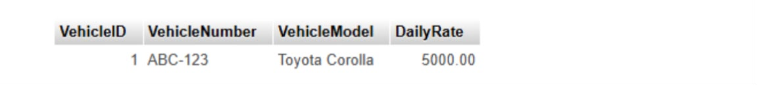

Rental
RentalID
CustomerID
VehicleID
RentalDate
ReturnDate
PaymentAmount
This decomposition ensures that customer information is stored in the Customer table and vehicle information is stored in the Vehicle table instead of being repeatedly stored with every rental.

12. Third Normal Form (3NF):
A table is in 3NF when:
- It is already in 2NF.
- There are no transitive dependencies.
The final structure separates information according to its main entity.

Customer Table
CustomerID
CustomerName
CustomerPhone
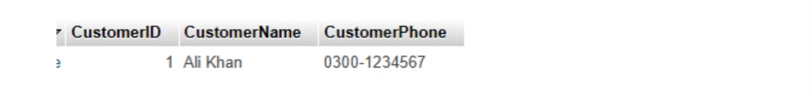

Vehicle Table
VehicleID
VehicleNumber
VehicleModel
DailyRate
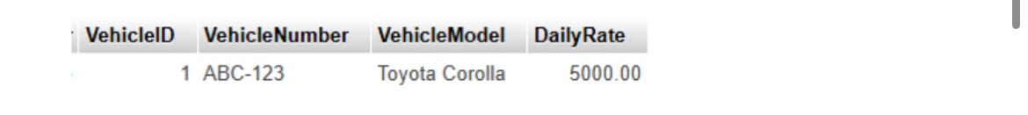

Rental Table
RentalID
CustomerID
VehicleID
RentalDate
ReturnDate


Payment Table
PaymentID
RentalID
PaymentAmount
PaymentDate

This structure reduces unnecessary duplication and makes the database easier to maintai

13. Data Anomalies Reduced by Normalization:
Normalization helps reduce three common types of anomalies.

Update Anomaly:
If a customer's phone number is stored in many rental records, changing the phone number requires updating multiple records.

Insert Anomaly:
It may be difficult to add a new customer or vehicle if the database requires a rental record at the same time.

Delete Anomaly:
Deleting a rental record could accidentally remove important customer or vehicle information if everything is stored in one table.
Normalization separates the data into logical tables and reduces these problems.

14. JOIN Queries:
JOINs are used to retrieve related information from multiple tables.
The lab requires four important JOIN queries.

Query 1 — Rental Details:
Display:
- Customer name
- Vehicle number
- Vehicle model
- Rental date
- Return date
This requires joining Customer, Rental, and Vehicle tables.
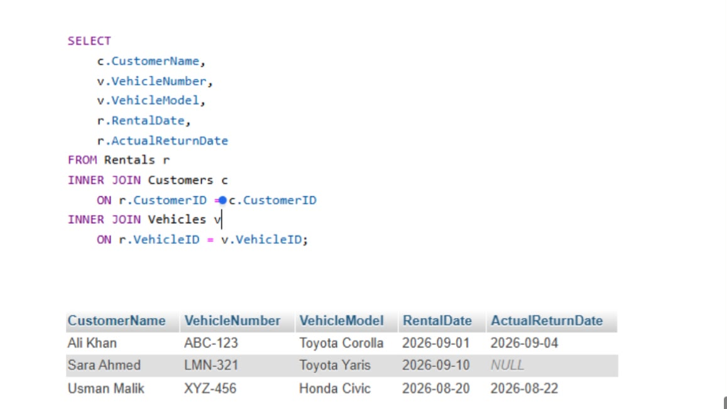

SELECT
c.CustomerName,
v.VehicleNumber,
v.VehicleModel,
r.RentalDate,
r.ReturnDate
FROM Rental r
JOIN Customer c
ON r.CustomerID = c.CustomerID
JOIN Vehicle v
ON r.VehicleID = v.VehicleID;

Query 2 — All Customers and Their Rentals:
Customers who have never rented a vehicle should also appear.
Therefore, a LEFT JOIN is appropriate.
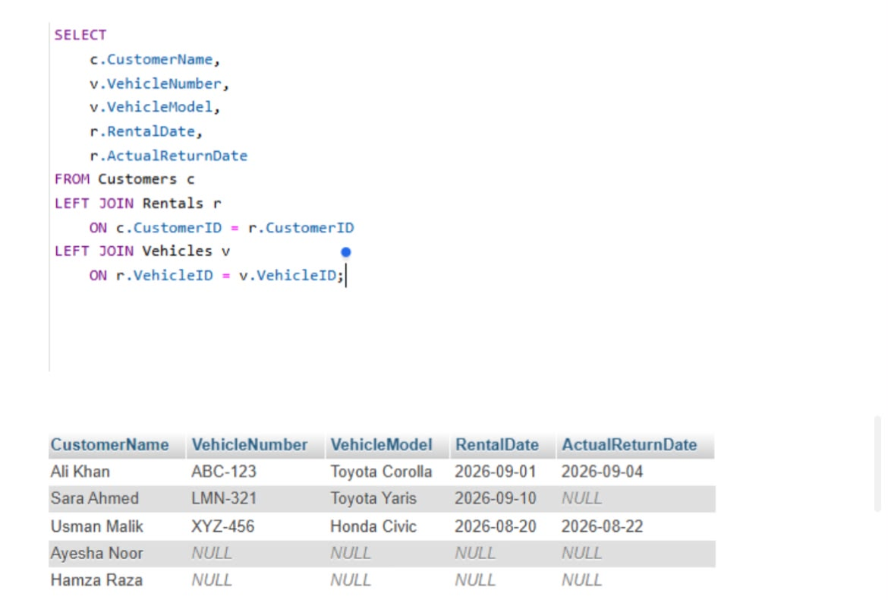

SELECT
c.CustomerName,
v.VehicleNumber,
v.VehicleModel
FROM Customer c
LEFT JOIN Rental r
ON c.CustomerID = r.CustomerID
LEFT JOIN Vehicle v
ON r.VehicleID = v.VehicleID;

Query 3 — All Vehicles and Current Rental Information:
All vehicles should appear, including vehicles that are not currently rented.
A LEFT JOIN can be used.
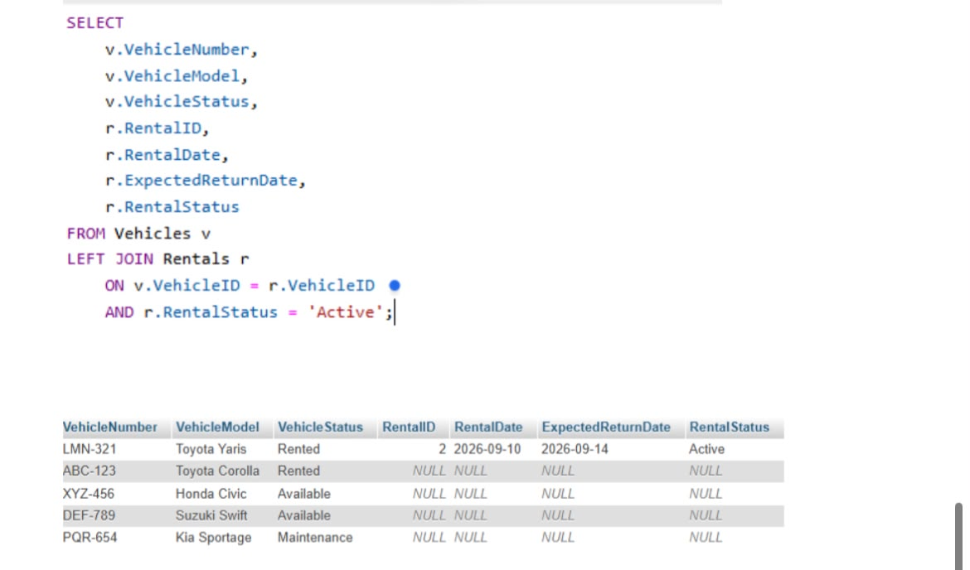
SELECT
v.VehicleNumber,
v.VehicleModel,
r.RentalDate,
r.ReturnDate
FROM Vehicle v
LEFT JOIN Rental r
ON v.VehicleID = r.VehicleID;

Query 4 — Total Rentals Per Customer:
This query should also include customers who have made zero rentals.
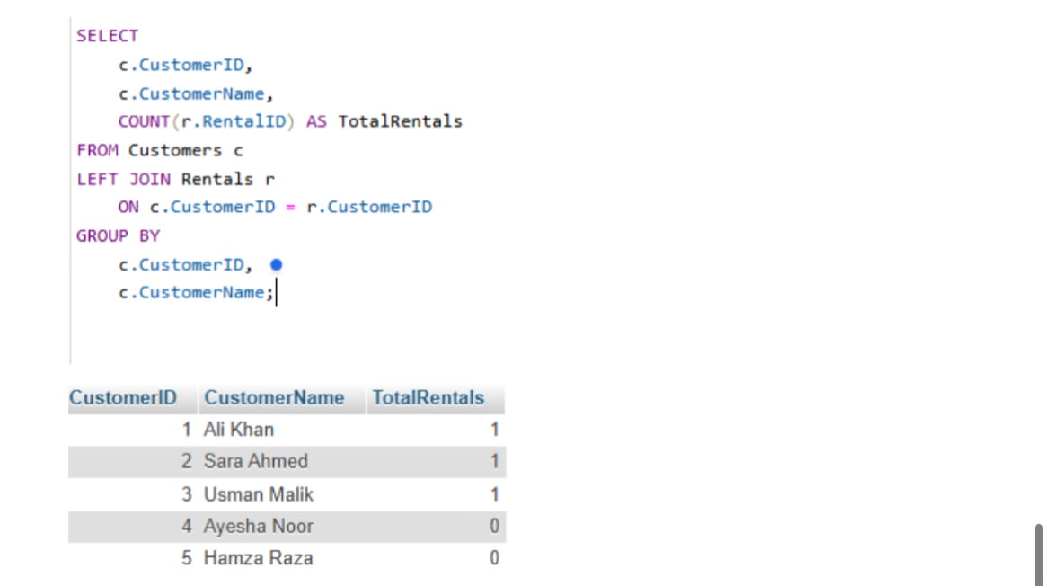
SELECT
c.CustomerName,
COUNT(r.RentalID) AS TotalRentals
FROM Customer c
LEFT JOIN Rental r
ON c.CustomerID = r.CustomerID
GROUP BY c.CustomerID, c.CustomerName;
The lab requires SQL statements and screenshots/output demonstrating the results of these queries.

15. VIEW:
A VIEW is a virtual table created from a SQL query.
A useful rental report VIEW can combine customer, vehicle, rental, and payment information.
Example:
CREATE VIEW RentalReport AS
SELECT
c.CustomerName,
c.CustomerPhone,
v.VehicleNumber,
v.VehicleModel,
r.RentalDate,
r.ReturnDate,
p.PaymentAmount
FROM Rental r
JOIN Customer c
ON r.CustomerID = c.CustomerID
JOIN Vehicle v
ON r.VehicleID = v.VehicleID
LEFT JOIN Payment p
ON r.RentalID = p.RentalID;

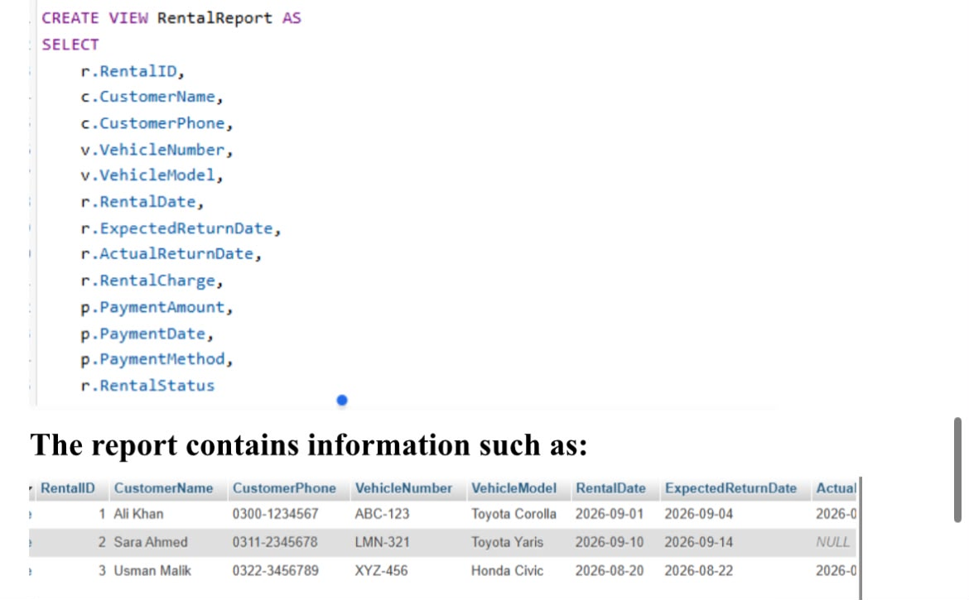
The VIEW makes it easier for management to obtain a consolidated rental report without repeatedly writing a complex JOIN query.
The lab specifically asks for one useful VIEW containing relevant customer, vehicle, rental, and payment information.

16. TRIGGER:
A TRIGGER is a database operation that automatically executes when a specified event occurs.
For this system, a trigger can be used to prevent a vehicle from being rented when it is already unavailable.
For example, before inserting a new rental, the database can check the vehicle's status.
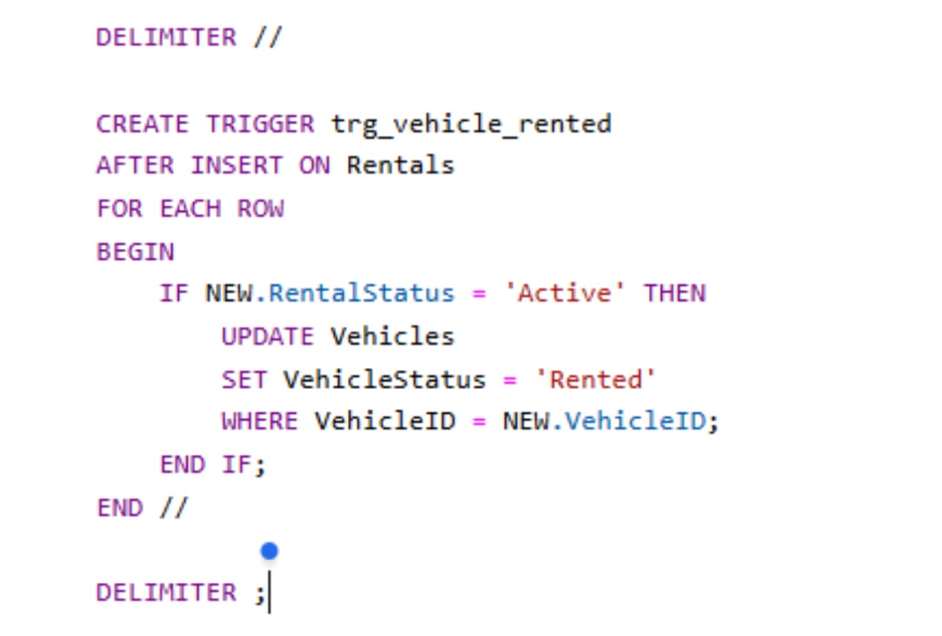
Conceptually:
IF VehicleStatus <> 'Available'
THEN
reject the rental
ELSE
allow the rental
END IF;
After a successful rental, the vehicle status can be changed from:
Available
to:
Rented
This supports the requirement that a vehicle should not be available for another rental while it is already rented.

17. Stored Procedure:
A stored procedure is a saved SQL program that performs a specific database operation.
For this project, a suitable procedure can be used to register a new rental and calculate its rental charge.
The procedure can accept:
- Customer ID
- Vehicle ID
- Rental date
- Return date
The basic calculation is:
Rental Charge = Number of Rental Days × Daily Rate
For example:
If:
Daily Rate = 5000
Rental Period = 3 days
Then:
Rental Charge = 3 × 5000
= 15000
The lab specifically suggests a stored procedure that registers a new rental and calculates the rental charge based on the rental period and vehicle's daily rate.

18. Optimization Analysis:
Database optimization improves performance and efficiency.
One possible inefficiency is repeatedly searching rental information by fields such as CustomerID, VehicleID, or RentalDate when these columns are frequently used in JOINs or filtering.
An appropriate improvement can be the use of indexes.
For example:
CREATE INDEX idx_rental_customer
ON Rental(CustomerID);
Another index can be created for vehicle searches:
CREATE INDEX idx_rental_vehicle
ON Rental(VehicleID);
Indexes can help the database locate records more efficiently when these columns are frequently searched or joined.
The lab requires identification of an inefficiency, explanation of its effect, an appropriate improvement, and demonstration of the improved design or query where applicable.

19. Testing and Verification:
After creating the database, the following features should be tested:

Database Creation:
Verify that the database and all tables are created successfully.

Data Insertion:
Insert realistic customers, vehicles, rentals, and payments.

Constraints:
Try invalid values to confirm that constraints work correctly.

JOIN Queries:
Execute all four required JOIN queries and save screenshots of the results.

VIEW:
Execute:
SELECT * FROM RentalReport;
and verify the consolidated rental information.

TRIGGER:
Attempt to rent an unavailable vehicle and verify that the database prevents the invalid operation.

Stored Procedure:
Execute the procedure with valid parameters and verify the calculated rental charge.
These screenshots and outputs are part of the required submission.

20. Expected Benefits:
The proposed database system provides several benefits:
- Reduces duplicate data.
- Improves data consistency.
- Makes customer information easier to manage.
- Makes vehicle availability easier to track.
- Simplifies rental management.
- Helps calculate rental charges.
- Provides useful management reports.
- Prevents invalid rental operations.
- Makes data retrieval easier through JOINs and VIEWs.
- Improves performance through suitable database optimization.

21. Conclusion:
The Car Rental Management System provides a structured relational database solution for CarGo Rentals. The system replaces spreadsheet-based management with connected relational tables for customers, vehicles, rentals, payments, and returns.
Normalization helps reduce redundancy and data anomalies. JOIN queries provide useful business information, while a VIEW provides a consolidated rental report. A TRIGGER can help enforce vehicle availability rules, and a STORED PROCEDURE can automate rental registration and charge calculation.
Finally, optimization techniques such as appropriate indexing can improve database performance. Overall, the project demonstrates important DBMS concepts including database design, normalization, constraints, JOINs, views, triggers, stored procedures, and optimization. The lab assesses these areas through five 4-mark criteria, for a total of 20 marks.

22. Submission Checklist:
Before submitting the lab, make sure the following are included:
- Database creation SQL
- Table creation SQL
- Primary keys
- Foreign keys
- Constraints
- Realistic sample data
- 1NF analysis
- 2NF analysis
- 3NF analysis
- Four required JOIN queries
- JOIN query screenshots/results
- VIEW
- TRIGGER
- STORED PROCEDURE
- Testing screenshots
- Optimization analysis
- Final short report
- One Complete sql file

